UNIT 8 – Physical Behavior of Matter - Test April 15, 2016
Kavanah pp. 57-77 Name _____________________

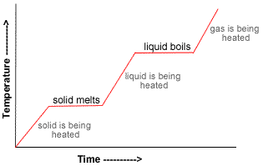

Heating and Cooling Curves

Phases of Matter – Review

Solid phase

Rigid

Definite volume and shape

Strong intermolecular forces hold particles in place with only small vibrations

Ex. ice, iron, aluminum

Liquid phase

Particles are able to move past each other

No definite shape, but liquids have a definite volume

Ex. water, ethanol

Gaseous phase

Very small intermolecular forces

No definite shape and no definite volume

Gases expand to fill the size of a container

Ex. nitrogen gas, oxygen, water vapor (vapor is the word used for substances that are liquid or solid under normal conditions)
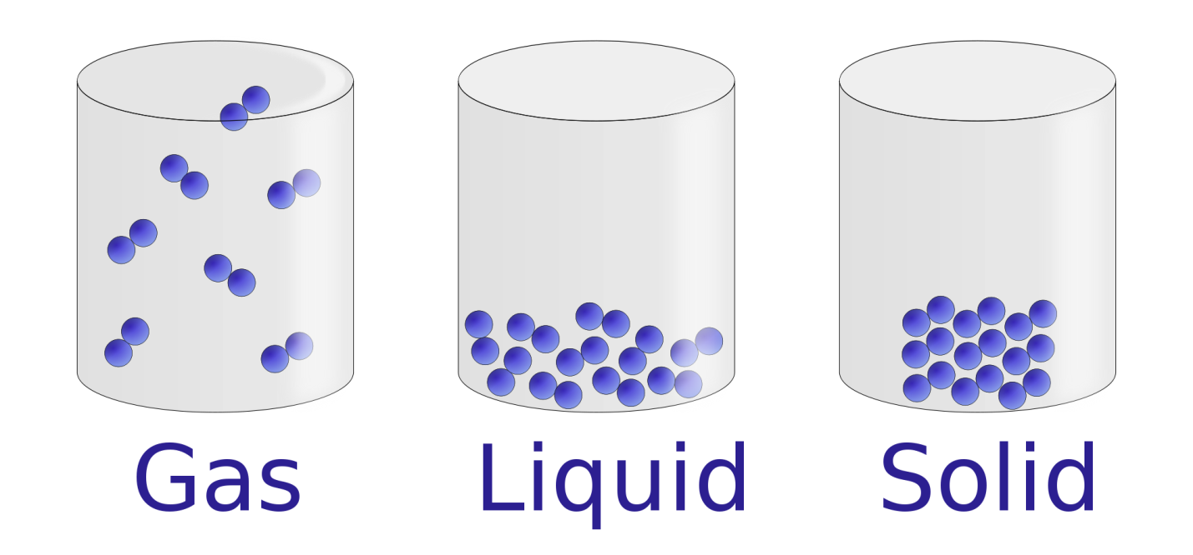

Reading the Heating Curve HW Kavanah 60-61

Solid section

Begin with ice in a very cold freezer.

What is freezing point of water? 0 Celsius

If ice is “supercooled” it is below 0 celsius.

Remove from freezer and slowly let it warm up. Measure temp every 15 seconds.

The ice will warm up but stay solid until it reaches its melting point. As it warms, the kinetic energy of the particles increases.

Kinetic energy – energy of motion. The particles vibrate more as temperature increases..

Melting (aka fusion)

Water molecules vibrate fast enough to break the bonds holding them in the solid phase

Even though heat is still added to the ice, the temperature does not increase

Phase changes (e.g. melting) occur at constant temperature. Kinetic energy of the particles stays the same.

Potential energy increases

Water and ice (solid and liquid) are both present

Melting is endothermic – heat is absorbed

The energy required to melt the ice is called heat of fusion

Liquid section

Now that all the H2O is in liquid form, it can begin to warm up

As energy is added to the water, the temperature increases

The temperature of a substance is directly proportional to the Kinetic Energy of the particles in degrees Kelvin

Therefore, kinetic energy increases

Temperature increases until the boiling point is reached

Boiling (aka vaporization)

Boiling begins when some of the particles have enough kinetic energy to break out of the liquid phase into the gas phase

During boiling, temperature remains constant.

Kinetic energy is constant, but potential energy increases

Liquid and vapor are both present

Boiling is endothermic

Gas section

Once all the water has turned to steam, and we continue to add energy, the temperature will increase

Kinetic energy increases as temperature increases

Heat Energy

Do now: Label a cooling curve

With these words

Kinetic energy

Potential energy

Boiling point

Freezing point

Solid, liquid, gas

Temperature HW Kavanah p. 63

Proportional to average kinetic energy of particles

Depends only on kin. energy, not on the amount

Ex. Which has greater kinetic energy? 10 g of water at 50 Celsius or 500 g of iron at 20 Celsius?

Answer: The water, because it is hotter.

Measured with a thermometer

Common thermometers are calibrated using the boiling point and freezing point of water

K = C + 273

Each degree is the same in Kelvin or Celsius, because there are 100 degrees between boiling and freezing

Degrees Fahrenheit are not so easy to convert, because there are 180 degrees between boiling and freezing
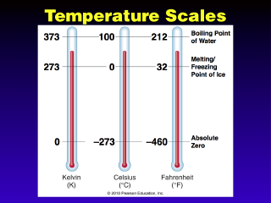

Heat

Heat and energy are NOT THE SAME

When 2 bodies have a temperature difference, heat will FLOW until the temperatures are equal

Heat is ENERGY

Heat flows from one place to another

heat is measured in claories or joules, not Kelvin or celsius

Ex. When requires more energy, melting 1 gram of ice or 10 grams of ice?

Ans: 10 grams of ice, because heat is energy and it depends on the amount of substance.

Heat of a temperature change

Formula is q=mCΔT (formula in Table T)

q is heat (in joules)

m is mass of substance (in grams)

C is specific heat capacity of substance (in Table B)

ΔT is change in temp. Final temp – initial temp.

Ex. How many joules are absorbed with 50.0 g of water are heated from 30.0 degrees to 60.0 degrees?
Ans: Write the givens.
q=(50 g)(4.18 J/ g C)(60-30)=6270 J

What is a calorimeter?

A device used by scientists to measure the amount of heat given off by a reaction

Reaction takes place in an insulated container filled with water.

Heat given off by exothermic reaction has to go somewhere. Where? Energy can never be created or destroyed.

Heat goes into the water and the temperature of the water rises.

You can calculate the amount of heat energy using the equation q=mCΔT

Calorimeter measure calories (or joules)

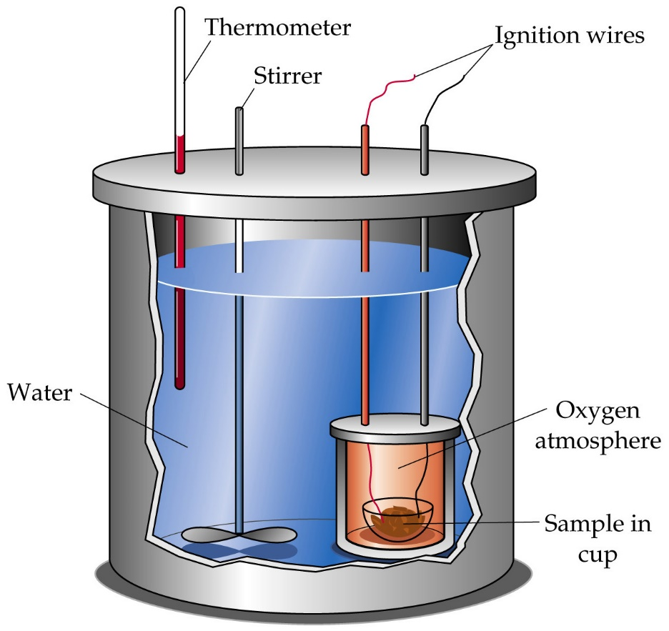

Heat of a phase change HW Kavanah p. 65

Review: what are the phase changes?
melting (aka fusion or freezing) and boiling (aka vaporization or condensation)

Phase changes occur at constant temp so I can’t use q=mCΔT formula

Use q=mH_{f} for solidliquid or liquidsolid phase change

Use q=mH_{v} for liquidgas or gasliquid phase change

Ex. How many joules are required to melt 100 grams of ice at 0 celsius?
Ans. Write the givens
q=100g x 334 J/g = 33400 J = 33.4 kJ

Melting is endothermic. Heat is absorbed and the potential energy increases.

Ex. How many joules of energy are required to vaporize 200. grams of water at 100 celsius?
Ans. Write the givens.
q=mH_{v} = 200 g x 2260 J/g = 452,000 J = 452 kJ

Gas Laws

Pressure

Force divided by area

Units are atmospheres, mm Hg (aka Torr), pascals, kilopascals, and pounds per square inch

1 atm = 760 mm Hg = 101.3 kPa = 14.7 psi

You can use any unit of pressure as long as you are consistent throughout the problem

Pressure is the collision of gas particles against the walls of the container

Boyles Law HW plot pressure vs volume data

When you push in a piston, pressure increases.

As you increase the pressure, the volume decreases.

P₁V₁=P₂V₂

Pressure and volume are inversely related P↑V↓

Ex. #47
What volume will a 300.0 mL sample of a gas at STP occupy when the pressure is doubled at constant temperature?
Same question if the pressure is cut in half?
Same question if I change the pressure from 1 atm to 1.5 atm?

Charles Law HW plot volume vs temperature

The volume of a gas is directly proportional to temperature when pressure is constant.

A balloon is at constant atmospheric pressure because the atmosphere is pressing on it

When you chill a balloon it contracts. When you heat it, it expands

Internal combustion engines run on Charles Law. The gases expand due to high temperature, pushing the piston down. Watch video.

Gay-Lussac Law

Memory crutch for the gas laws

Table T combined gas law

Move clockwise in alphabetical order

The pressure of a gas is directly proportional to the temperature when you hold the volume constant.

Caution: Never throw an aerosol can into the fire!

Why not? Volume is held constant by the can. Temp causes pressure build up until the can explodes.

Combined Gas Law

This is the only law I use. I just cross out the variable that is not being used in in the particular example.

Combined gas law is in Table T.
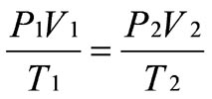

Ideal Gases PV=nRT (extra credit extension topic)

Kinetic Molecular Theory HW Kavanah p. 66

Theory

Review: A theory is a model that is used to explain some aspect of the natural world that is repeatedly tested and confirmed through observation and experimentation.

Compare to theories of the atom.

KMT explains the observations about gases that Boyle, Charles, Gay-Lussac, Avogadro, and other scientists have made.

Major ideas of KMT

Gases contain particles (atoms like He or molecules like H₂) that are in constant, random, straight-line motion. Whiz! Whiz!

Gas particles collide with each other and with the walls of the container, but no net energy is lost in these collisions. This is called an elastic collision (Physics preview)

Gas particles are far apart.

The volume of each gas particle is so small that it is negligible.

Gas particles do not attract each other (no IMF).

Ideal vs real gases

KMT is based on an “ideal” gas with all of the above properties.

It is a good approximation, but real gases behave slightly differently.

There is some attraction between gas particles, ex. water vapor molecules combine to form snow and rain.

Gas particles do have some amount of volume

When do gases look more “ideal”?

Low pressure gas particles are more spread out so there is less chance of collision and volume of container is much bigger than volume of particles

High temperature

Low mass smaller particles like He and H₂ have lower IMF

Avogadro’s Hypothesis

When P and T are all the same, an equal number of particles always has the same volume, regardless of the gas.

Ex. 12 L of nitrogen has the same number of molecules as 12 L of oxygen at STP

1 mole of any gas has a volume of 22.4 liters at STP

1 mole of any substance contains 6.02 x 10²³ particles

