UNIT 7 – Math of Chemistry - Test March 18, 2016
Kavanah pp. 45 - 56 Name _____________________

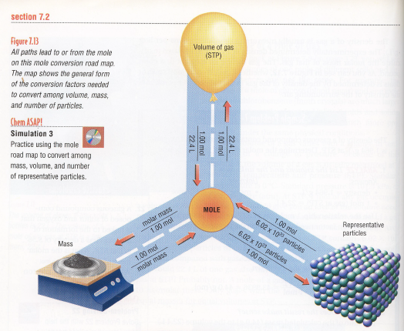

Formula Mass

Atomic mass

Weighted average of the masses of the existing isotopes of an element

On periodic table, OK to round to make the math easier

Measured in a.m.u., atomic mass units

Gram atomic mass HW worksheet #1

The mass of one mole of an element

Measured in grams

Same number as atomic mass

Ex. What is mass of one atom of iron? What is the mass of one mole of iron atoms?

Formula Mass

Sum of the atomic masses of all the atoms in a compound

Mulitply each atomic mass by the subscript

Measured in a.m.u.

Ex. H₂O
H – 2 x 1 = 2
O – 1 x 16= 16
18

Ex. CaCO₄ formula mass is 100 amu

Ex. H₂SO₄ formula mass is 98 amu

Gram formula mass (gfm) HW Kavanah p.47 # 11-13

The formula mass of a substance expressed in grams instead of amu

The mass of one mole of a substance

Gram molecular mass and molar mass (MM)

Molecule – a covalently bonded compound

Some books (and tests) say “gram molecular mass” instead of “gram formula mass” when talking about molecules.

Molar mass (MM) is a general term for gram atomic mass, gram formula mass, or gram molecular mass

Percent Composition

Part/whole HW Kavanah p. 48

What is the percent mass of your head?

Look for formula in Table T

% composition by mass = mass of part/mass of whole x 100

Ex. What is the percent by mass of carbon in CO₂?

Step one – determine the formula mass of CO₂
C – 1 x 12 = 12 amu
O - 2 x 16 = 32 amu
44 amu

Step two - What is the mass of the “part” (in this case carbon)?
C – 12 amu

Step three – Divide part over whole to find percent composition

Answer – 27%

Ex. What is the percent by mass of nitrogen in NH₄NO₃?

formula mass is 80 g

mass of N is 2x14=28 g

28/80 x 100 = 35%

Percent water in a hydrate HW Kavanah p 49 #24-26

Review: Ionic substances often include definite amounts of water as part of the crystal structure

Water molecules are shown as part of the formula, separated by a dot

ex. CuSO₄ · 5H₂O means there are 5 water molecules per unit of copper II sulfate

Anhydrous means that no water is incorporated into the crystal

Treat the water molecule as a single unit with a formula mass of 18 amu when calculating percentage of water in a hydrate

Ex. What is the percentage by mass of water in CuSO₄ · 5H₂O?

formula mass is 159.5 + 90 = 249.5 amu

mass of water is 5 x 18 = 90 amu

percent water is 90/249.5 x 100 = 36%

Ex. What is the percent of water in sodium carbonate with ten waters

formula mass is 286 g

Mass of water is 180 g

percent water is 180/286 x 100 = 62.9% water

Hydrate Lab HW Lab Report

Mole / Mole Wheel HW Kavanah p. 50 show your work

Mole

Analogy: how many pencils in a dozen pencils? 12
How many eggs in a dozen eggs? 12
A dozen always means 12 of whatever,

A mole is always 6.02 x 10²³ of whatever

Ex. How many Neon atoms in a mole of neon?
How many electrons in a mole of electrons?

Mole definition: the number of atoms of carbon-12 in a 12.000 gram sample

Abbreviation: mol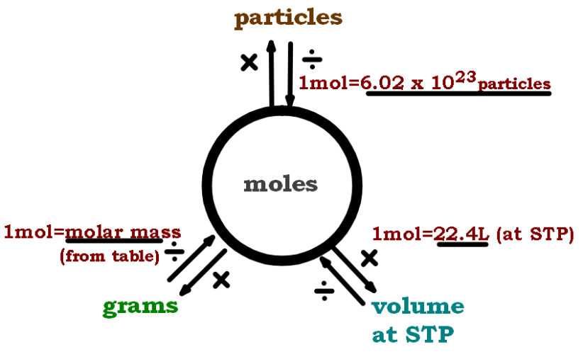

Particles to moles HW Mole Conversion Mini Workout

Draw the mole wheel on the board

Use Avogadro’s number 6.02 x 10²³

DIMO – divide in, multiply out

Find the EE button on your calculator. Practice entering Avogadro’s number

Ex. How many atoms in 2.6 mol Na? 1.6 E24

Ex. How many molecules in 3.8 mol CO₂? 2.3 E24

Grams to moles

Avogadro’s number is so awkward. Why do we use it?

Avo is the conversion from a.m.u. to grams.

The gfm of any substance is the mass of one mole of that substance.

DIMO using the gfm

Ex. How many grams are in 40.5 mol of sulfuric acid? 3970 g

Look at example of NO on homework worksheet. How many moles are equivalent to 45 grams of NO?

Liters to moles

Review: gases are rapidly moving molecules.

Volume of actual molecule is very small compared to size of the container.

Therefore, all gases take up the same amount of volume, regardless of what gas it is.

Molar volume is 22.4 liters of gas at STP

Volume depends on temperature and pressure, so STP is 0 celcius and 1 atmosphere.

Use the mole wheel.

Ex. from worksheet: CO₂ – What is volume of 2 moles of CO₂ at STP?

Ex. from worksheet H₂O₂ – How many moles of hydrogen peroxide is 11.2 liters at STP?

Finding the Molecular Formula HW Kavanah p. 51 Show your work

Find the molecular formula if the empirical formula and molecular mass are both known

A molecule as the empirical formula CH₂ and molecular mass of 42 amu. What is the molecular formula?
Guess: it could be CH₂, C₂H₄, etc.

Step 1 - Calculate gfm of the empirical formula.
What is gfm of CH₂? 14

Step 2 - Divide molecular mass of the compound by the formula mass of the empirical formula.
Divide 42 amu by 14. 42/14=3

Step 3 - Multiply each subscript by that number
Molecular formula is C₃H₆

Ex. A compound has a molecular mass of 180 amu and an empirical formula of CH₂O. What is its molecular formula?
Step 1 – Find gfm of empirical formula:
C 1x12 = 12
H 2x1=2
O 1x16=16
30 amu
Step 2 – Divide molecular mass by empirical mass:
180/30=6
Step 3 – Multiply all subscripts of empirical formula by 6:
C₆H₁₂O₆

Stoichiometry

Balancing review HW Kavanah p. 36 SHOW YOUR WORK

Change coefficients in order to conserve mass in the reaction

Atoms of reactants are same as atoms of products

Some equations can be balanced just by looking at them.

If harder, list all elements underneath and the number of atoms of each element.

Hint: Keep polyatomic ions together if they are unchanged

Use examples from worksheet

Ex. Ca(OH)₂ + (NH₄)₂SO₄ CaSO₄ + NH₃ + H₂O

Ex. C₃H₈ + O₂ H₂O + CO₂

Mole ratios in balanced equations

Balance this equation:
2 C₂H₆ + 7 O₂ 4 CO₂ + 6 H₂O

Qualitative information: formulas of compounds. From the formula you can know the behavior, color, smell, etc.

Quantitative information: coefficients. How much of each compound.

Coefficients can represent molecules, moles, or ratios of moles.

Ex. When 2 molecules of ethane react, how many molecules of water are formed?

Ex. When 2 moles of ethane react, how many moles of water are produced?

Ex. When 4 moles of ethane react, how many moles of water are formed?

The numbers can change, but the ratio has to stay the same.
2 C₂H₆ + | 7 O₂ |  | 4 CO₂ + | 6 H₂O
Moles C₂H₆ | Moles O₂ |  | Moles CO₂ | Moles H₂O
2 | 7 |  | 4 | 6
4 | 14 |  | 8 | 12
1 | 3.5 |  | 2 | 3

Ratio of moles is always the same!

Solving Mole-Mole Stoichiometry problems

Solve use ratios! Easy!

Ex. What amount of oxygen is needed to completely react with 3 moles of methane in a combustion reaction?

Step 1 – Always start with a balanced equation:
CH₄ + 2O₂ CO₂+ 2H₂O

Step 2 – Write the given number of moles aver that coefficient.

Write x over the coefficient of the unknown quantity.

Solve the ratio for x. That is the number of moles you are looking for.

Ex. Kavanah p. 54 #54

Ex. Kavanah p. 54 #55 HW Kavanah p. 54 #54-61 SHOW YOUR WORK

Solving volume-volume stoichiometry problems

Volume is proportional to number of moles for any gas at STP

So you can still use ratios!

Ex. Haber process
Balance this equation
N₂ + 3H₂ 2NH₃
What volume of hydrogen is necessary to react with 5 liters of nitrogen to produce ammonia?

Solving Harder Stoichiometry problems

Solve using ratios. Still easy!

Include the factor to convert to moles when needed.

Grams moles. Use gfm

Liters of gas moles. Use 22.4

molecules of compound to moles use 6.02 x 10²³

Over / Under / Solve HW Worksheet #__

Examples from worksheet

Extra Credit “Extension” Topics HW MgO Lab

Find Empirical Formula from data about mass

HW Lab Report

Finding empirical formula

If you analyze a compound in the lab and find out the mass of each component, you can determine the empirical formula

Divide the mass of each element by the gfm of that element to find moles

Find the smallest whole-number ratio by dividing each mole value by the smallest number of moles

Ex. What is empirical formula of a compound that is 75.0% carbon by mass and 25.0% hydrogen by mass?
Step 1 – Assume you have 100 grams of the compound.
Step 2 – Divide each mass by the gfm. Use 3 sig figs:
C – 75 g/12.0 g = 6.25 mol
H – 25 g/1.01 g = 24.75 mol
Step 3 – Divide each value by the smaller value:
C – 6.25/6.25=1.00
H – 24.75/6.25=3.96
Step 4 – Round to whole numbers, and write the empirical formula! CH₄

Limiting Reagent HW Kavanah p. 54 #63-64

Cheese sandwich analogy

Recipe is 2 slices of bread, 1 slice of cheese

If I have 4 slices of bread and 4 cheese, how many sandwiches can I make? Answer: 2 sandwiches
Which ingredient was limiting? bread

If I have 10 slices of bread and 4 slices of cheese, how many sandwiches? 4 sandwiches
Which ingredient was limiting? cheese

Limiting reagent stoichiometry

Reagent and reactant are synonyms

Ex. Hydorgen gas and chlorine gas react to form hydrogen chloride. If 2 mol of hydrogen gas are mixed with 4 mol of chlorine gas, how many mols of hydrogen chloride will be produced?

Step 1 – Start with a balanced equation.

Step 2– Solve the stoichiometry problem twice, once for each reactant..

Step 3 – Which reactant gives you less product? That is the limiting reagent.

Step 4 – The other reactant is in excess.

Percent Yield

